RE: *Johanna Mangual v Liliana C. Leider et al., Case No: 2023-CA-002016, Circuit Court of the Eighteenth Judicial Circuit, in and for Seminole County, Florida*

Date of Crash: March 1, 2023

Date of Birth: *Johanna Mangual:* March 13, 1982 [40 years old at time of crash]

**Background Facts:**

On March 1, 2023, at about 5:50 pm Johanna Mangual was the restrained driver of a 2019 Ford Fusion 4DR sedan that was northbound on US-17-92, at the intersection of FL-419, Seminole County, Florida. An unknown vehicle and driver located two vehicles ahead of her suddenly stopped in the straight only-through lane to make a left turn. That vehicle was struck in the rear by a 2019 Toyota Tundra pickup, driven by David Negron, that was behind it and in front of Ms. Mangual. Ms. Mangual’s Ford was then struck from the rear by a 2021 Volkswagen Tiguan SUV, driven by Liliana Leider, and due to that impact Ms. Mangual’s Ford struck the rear of the Toyota. There were differing accounts of the mechanics of the subject crash by those involved. The images below depict a satellite view of the subject intersection, the police diagram and the subject Ford, post-collision:

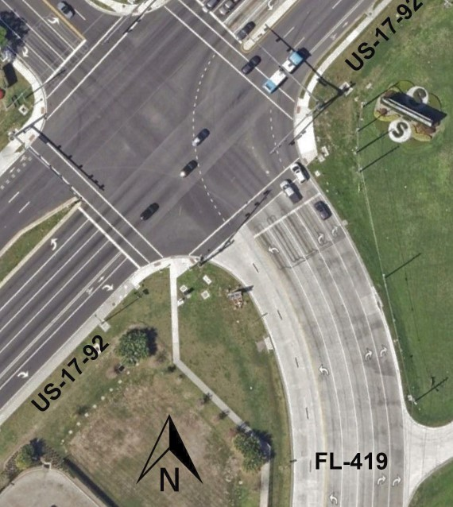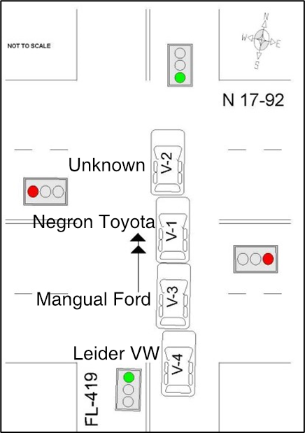

**Satellite view of subject intersection, imagery date 3/19/2022**

**Police diagram, Ms. Mangual’s**

**Ford is (labels added)**

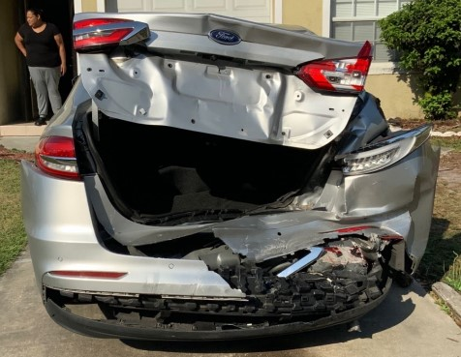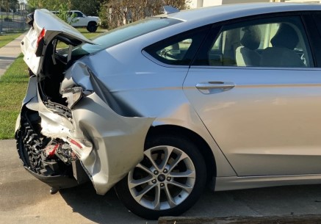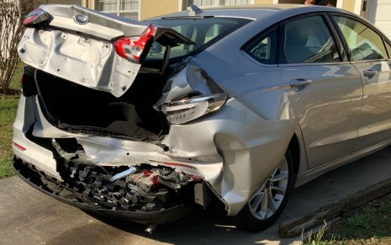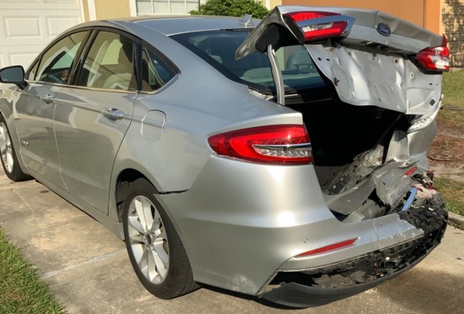

**Ms. Mangual’s Ford, post-collision, first impact**

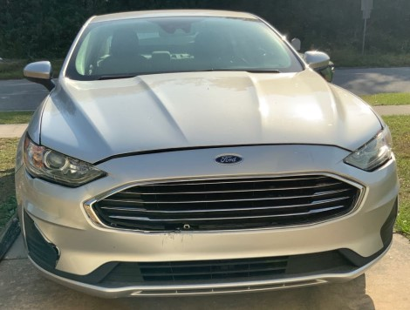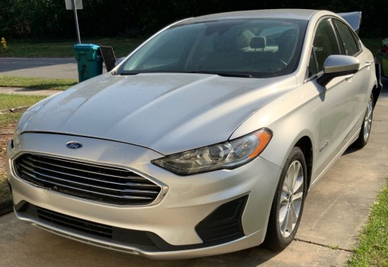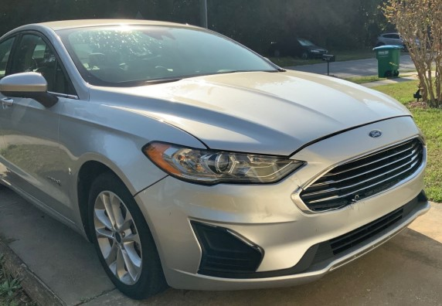

**Ms. Mangual’s Ford, post-collision, second impact**

No damage estimate was provided for the Ford for review. The provided photos showed damage to the rear bumper assembly (bumper cover, valance panel, impact absorber, impact bar), right rear lighting assembly, trunk lower panel, trunk lid, rear floor pan, right rear quarter panel, front bumper cover, front upper grille and there was misalignment between the front bumper cover, hood and both front lighting assemblies. The Ford was towed from the scene and no air bag deployment occurred.

No damage estimate or photos were provided for the Toyota for review. The police report described the damage as minor with an estimate of $1,000. The Toyota was not towed from the scene and there was no report of air bag deployment.

No damage estimate or photos were provided for the Volkswagen for review. The police report described the damage as disabling with an estimate of $10,000. The Volkswagen was towed from the scene and there was no report of air bag deployment.

*Post-crash history*

Ms. Vega was restrained; she had both hands on the steering wheel. On impact her head struck the headrest. Immediately after the crash she felt disoriented.

Ms. Vega presented to the South Seminole Hospital ED at 2125, around 4 hours after the crash, with complaints of pain in her lower back and left arm. On examination her left arm was mildly swollen and bruised, and she had pain to palpation over the midline thoracic and lower spine and paraspinal muscles. Ms. Vega underwent an X-ray of the left humerus and CT scans of the entire spine which were negative for acute osseous abnormality. She was diagnosed with acute bilateral low back pain, acute left arm pain, prescribed Robaxin and Naproxen and released home.

On March 3, 2023, 2 days after the crash, Ms. Vega presented to Dr. Trevor Lauffer (chiropractic). Dr. Lauffer initiated treatment modalities, for the lower back and left arm, ordered an MRI of the lumbar spine, and referred Ms. Vega for medical evaluation.

On March 14, 2023, Ms. Vega underwent the lumbar MRI which revealed: at L3-4, a central disk herniation with disk bulging, moderate central canal stenosis; at L4-5, posterior disk herniation and moderate to severe central canal stenosis; at L5-S1, a left foraminal disk herniation superimposed on a disk bulge and osteophyte formation, and mild to moderate central canal stenosis.

On March 17, 2023, Ms. Vega presented to Sharon Taranto ARNP for post-crash medical evaluation. She had moderate to severe constant pain in her low back and left shoulder. Ms. Taranto diagnosed left shoulder pain, low back pain, prescribed Naproxen 500 mg, Methocarbamol 500 mg and recommended continuing conservative care.

On March 24, 2023, Ms. Vega presented to Kindall Shedrick NP. She had pain radiating from her lower back to her right buttock and hip. Ms. Shedrick diagnosed lumbar disk displacement, lumbosacral radiculopathy/stenosis, muscle spasms and lumbar dorsopathies. She recommended continuing conservative care and lumbar radiofrequency neurotomies with persisting symptomatology/diabetic clearance (refer below).

Ms. Vega underwent treatment modalities with Dr. Lauffer (chiropractic) through June 1, 2023.

On August 22, 2023, Ms. Vega presented to Catherine Hurley APRN with persistent right lumbar radicular symptoms. Ms. Hurley scheduled Ms. Vega for radiofrequency neurotomies.

On October 19, 2023, Ms. Vega underwent lumbar radiofrequency neurotomies, of the medial branches of L3 and 4, bilaterally, and the dorsal ramus of L5, performed by Dr. Sidney Swartz (anesthesiology). Ms. Vega appreciated approximately only 10% symptom relief.

On December 7, 2023, Ms. Vega returned to Kindall Shedrick NP. She discussed proceeding with a lumbar microdiscectomy and foraminotomy at L5-S1.

On January 9, 2024, Ms. Vega presented to Dr. Ryan DenHaese (neurosurgery) with persistent ‘stabbing’ pain in her lower back radiating through her buttocks and into the left [proximal posterior] leg. Dr. Denhaese reiterated recommendations for undergoing a left lumbar microdiscectomy at L5-S1. Height: 5 ft 7 inches, weight: 308 lbs.

*Pre-crash medical history*

(Type 2 Diabetes)

Non-contributory to post-crash diagnoses

**Documents reviewed**

Florida Traffic Crash Report

Complaint

South Seminole Hospital ED

Orlando Center for Outpatient Surgery

Complete Care Centers for Imaging, Open MRI

Integrative Physical Medicine of Casselberry, Dr. Lauffer

Interventional Associates of Orlando

Complaint (complaint-719057.pdf)

Defendant, Liliana C. Leider’s Answers To Interrogatories

Police crash report (CrashReport_25741387.pdf)

15 color photographs (Pictures 23-005343 Johanna Vega Mangual-663764.pdf)

Ms. Mangual’s Orlando Health South Seminole Hospital ED records

Ms. Mangual’s Complete Care Initial Evaluation medical records

*Reconstruction:*

According to the police report it was daylight, clear and the roadway was dry. The speed limit on FL-419 and N US 17-92 was listed in the report as 45 mph. A review of satellite imagery, in street view mode, revealed the speed limit on FL-419 was 30 mph and the speed limit on US 17-92 was 45 mph.

No deposition of Ms. Mangual was provided for review. In her Orlando Heath South Seminole Hospital ED medical records, dated March 1, 2023, she told medical professionals that she was rear-ended and that she also rear-ended the car ahead of her. The crash was at a low rate of speed and her car was drivable. In her Initial Evaluation with Complete Care Centers medical records, dated March 24, 2023, she told medical professionals that she was rear-ended by another vehicle and due to that impact, her vehicle struck the vehicle in front of her. She was wearing her seat belt, the air bags did not deploy, and her head hit the headrest.

No deposition of Ms. Leider was provided for review. In Defendant, Liliana C. Leider’s Answers To Interrogatories she said she was traveling on SR 419 approaching the intersection of US 17-92 and had a green traffic light. An unknown vehicle that was 3 vehicles ahead of her suddenly stopped in their lane, which was a straight only lane, to make a left turn. The Toyota pickup truck behind it rear-ended it and then the Toyota pickup was rear-ended by Ms. Mangual’s Ford. She applied her brakes but was not able to stop in time. The driver in the vehicle that suddenly stopped to make a left turn fled the scene. Ms. Mangual contributed to the subject crash by following the Toyota too closely and rear-ended it.

No deposition or statement from Mr. Negron was provided for review.

The police report, authored by Deputy Correa, stated that all 4 vehicles were northbound on FL-419. When Mr. Negron arrived at the intersection in his Toyota, he failed to maintain the proper distance from the unknown vehicle/driver ahead of him and his front bumper struck the rear bumper of it. Ms. Mangual, in her Ford, did not maintain a proper distance and her front bumper struck the rear bumper of Mr. Negron’s Toyota. Ms. Leider failed to maintain a proper distance and her front bumper struck the rear bumper of Ms. Mangual’s Ford. The unknown driver of the unknown vehicle fled the scene and was never located. The estimated speeds of the vehicles were:

* Ms. Mangual’s Ford, designated as V3—25 mph
* Mr. Negron’s Toyota, designated as V1—25 mph
* Ms. Leider’s Volkswagen, designated as V4—30 mph
* Unknown driver/vehicle, designated as V2—15 mph

*Crash Analysis:*

Deformation to the rear of the Ford would indicate a moderate speed impact with some override by the Volkswagen. Estimated deformation to the rear of the Ford is over 6+ inches. There is some minor damage to the front of the Ford and would estimate deformation around 2-3 inches but could be more if substructures were damaged. Based on the relative damage to front of the Ford, it is likely the Toyota was still moving when the Ford collided into it.

A widely used crash simulation program[1] is capable of modeling deformation and depth of penetration or maximum engagement during a collision. By overlapping the damage between scale models of the involved vehicles, as observed in the photos, I can model the subject crash to determine a closing speed estimate, which will in turn, estimate an approximate speed change or delta V imparted to the Ford in the crash by using a momentum, energy and restitution (MER) analysis, and then matching these results to the physical and other evidence.

A closing speed of 20 mph from the Volkswagen would have resulted in a delta V in the Ford of approximately 12.0 mph, with a peak vehicle acceleration for the impact of approximately 8.8 g. This likely resulted in a closing speed of approximately 10 mph between the Ford and Toyota that would produce a delta V of approximately 7.5 mph and a peak acceleration of 5.5 g in the Ford. Deformation (overlap or depth of penetration) between the Volkswagen, the Ford and the Toyota is shown below and is fairly consistent with what is observed in the photos.

**Simulated 20 mph depth of penetration (overlap or maximum engagement) between the Volkswagen and Ford (left photo) and 10 mph overlap between the Ford and Toyota (right photo) which is fairly consistent with photos. Ms. Mangual’s Ford is the vehicle in blue.**

1. Virtual Crash 5, vCrash America Inc.